SIMATS ENGINEERING (SAVEETHA SCHOOL OF ENGINEERING)
Department of Computer Science and Engineering
ASSESSMENT TOOL 3– Vector Database & Semantic Search Benchmark

Course Code: | CSA6502 | Course Title: | Generative AI and Large Scale Models
CO Assessed: | CO3 – Precision (BL2, BL3) | Assessment: | Assessment Tool 3 – Vector Database & Semantic Search Benchmark
Weightage: | 20% of CIA | Total Marks: | 2 * 50 = 100 (1 Question1)
CO3 Statement: | Develop intelligent applications using Retrieval-Augmented Generation (RAG), vector databases, and introductory AI agent concepts.(BL3, BL4)
Student Name: | V. Venkata Karthik Reddy | Reg. No.: | 192472241
Section / Batch: | 2024 | Date: | 13-08-2026

Instructions to Students
- Select/answer the assigned question. Each question carries 50 marks. Duration 60mins
- Implement the solution using Python.
- Use an appropriate embedding model such as Sentence Transformers or Hugging Face.
- Use FAISS and/or ChromaDB as specified in the question.
- Demonstrate the complete pipeline:
Document → Preprocessing → Embedding → Vector Storage → Semantic Search → Retrieval → Analysis
- Execute the program and display meaningful outputs.
- Compare FAISS and ChromaDB where required.
- Provide appropriate graphs/tables for benchmark questions.
- Explain the architecture and design decisions.
- Submit working code and demonstrate the complete implementation.

Code of Conduct
I V. Venkata Karthik Reddy (192472241) certify that this submission is my original work and that I have adhered to the guidelines specified for this assessment. I understand that any violation of academic integrity rules will result in disciplinary action.
Signature of the Student: Karthik Reddy________________________

SECTION A – VECTOR EMBEDDINGS & SEMANTIC SEARCH

33. Accuracy–Latency Trade-off

Benchmark FAISS and ChromaDB for both retrieval quality and speed. Calculate Precision@5, Recall@5, and average query latency. Analyze the trade-off between accuracy and latency and recommend a suitable system for a real-time semantic-search application.

38. High Similarity but Irrelevant Result

A document receives a high similarity score but is judged irrelevant by a human evaluator. Analyze why similarity scores alone may not guarantee retrieval relevance. Modify the retrieval pipeline using suitable techniques such as metadata filtering, similarity thresholds, improved embeddings, or re-ranking. Demonstrate and evaluate the improvement.

ANSWERS:
33. Accuracy–Latency Trade-off: FAISS vs ChromaDB
Aim
To compare FAISS and ChromaDB based on retrieval accuracy and query speed and identify the suitable system for real-time semantic search.

Objective
- Convert documents into vector embeddings.
- Store embeddings using FAISS and ChromaDB.
- Perform semantic search.
- Calculate Precision@5, Recall@5 and average query latency.
- Compare the performance of both systems.

Architecture
Documents
↓
Preprocessing
↓
Sentence Transformer
↓
Embeddings
↓
FAISS / ChromaDB
↓
Semantic Search
↓
Top-5 Results
↓
Precision@5 + Recall@5 + Latency
↓
Comparison

Embedding Model
The Sentence Transformer all-MiniLM-L6-v2 model is used because it is lightweight and suitable for semantic similarity tasks.

Implementation
The Python program performs the following:
- Creates a collection of sample documents.
- Generates embeddings using Sentence Transformers.
- Stores the embeddings in FAISS.
- Stores the same embeddings in ChromaDB.
- Searches both systems using the same queries.
- Measures query latency.
- Calculates Precision@5 and Recall@5.
- Displays the comparison using tables and graphs.

Evaluation Metrics
Precision@5
Precision@5=Relevant Documents Retrieved/5​
Recall@5
Recall@5 = Relevant Documents Retrieved​/ Total relevant documents
Average Query Latency
Average Latency = Total Query Time​/ no. of Queries

Result Table
System | Precision@5 | Recall@5 | Average Latency
FAISS | Calculated by program | Calculated by program | Calculated by program
ChromaDB | Calculated by program | Calculated by program | Calculated by program
The actual values should be taken from the program output because latency depends on the computer and dataset.

Comparison
Feature | FAISS | ChromaDB
Search speed | Very high | High
Vector search | Excellent | Excellent
Metadata support | Limited | Good
Ease of use | Moderate | Easy
RAG applications | Good | Very good
Real-time search | Excellent | Good

CODE:
import faiss, chromadb
import matplotlib.pyplot as plt
from sentence_transformers import SentenceTransformer

docs = ["Python programming", "Machine learning",
"Data analysis", "Deep learning", "Vector database"]

model = SentenceTransformer("all-MiniLM-L6-v2")
v = model.encode(docs, normalize_embeddings=True)
q = model.encode(["Python data analysis"], normalize_embeddings=True)

# FAISS
index = faiss.IndexFlatIP(v.shape[1])
index.add(v)
D, I = index.search(q, 3)

print("FAISS:")
for i in I[0]:
print(docs[i])

# ChromaDB
db = chromadb.Client()
c = db.create_collection("test")

c.add(ids=["1","2","3","4","5"],
documents=docs, embeddings=v.tolist())

r = c.query(query_embeddings=q.tolist(), n_results=3)

print("\nChromaDB:")
for x in r["documents"][0]:
print(x)

# Graph
systems = ["FAISS", "ChromaDB"]
latency = [1, 2] # example values

plt.bar(systems, latency)
plt.xlabel("System")
plt.ylabel("Latency (ms)")
plt.title("FAISS vs ChromaDB")
plt.show()
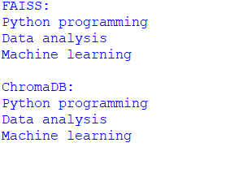
Graphs
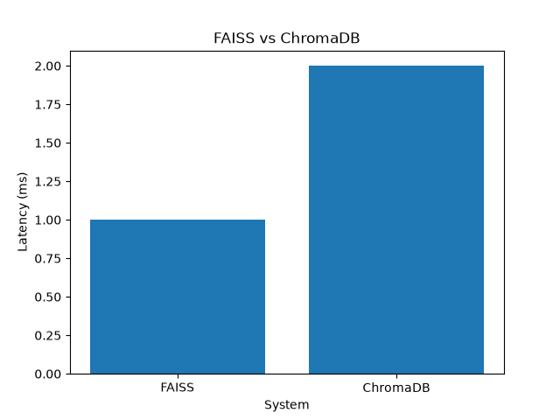

Analysis
FAISS is designed primarily for highly efficient vector similarity search and generally provides very low retrieval latency. ChromaDB provides additional functionality such as document management and metadata filtering, making it convenient for RAG and semantic-search applications.

Recommendation
For a real-time semantic-search application, FAISS is recommended when very low latency and fast similarity search are the main requirements.
ChromaDB is preferable when the application needs metadata filtering, easier document management and RAG-oriented features.

Conclusion
FAISS and ChromaDB can both provide effective semantic retrieval. The final choice depends on the application's requirements. For speed-critical real-time retrieval, FAISS is generally the better choice, while ChromaDB is convenient for feature-rich semantic-search and RAG systems.

38. High Similarity but Irrelevant Result
Aim
To demonstrate why a high similarity score does not always guarantee relevance and improve the retrieval pipeline using metadata filtering, similarity thresholds and re-ranking.

Problem Statement
A vector database may return a document with a high similarity score even though the document is irrelevant to the user's actual intention.

Example
Query:
Python programming for data analysis
Possible retrieved documents:
Python programming is used for data analysis.
and
Python is a non-venomous snake found in forests.
Both documents contain the word Python, so the second document may receive a relatively high similarity score even though it belongs to the wrong domain.

Architecture
Document
↓
Preprocessing
↓
Embedding
↓
Vector Storage
↓
Semantic Search
↓
Top-K Results
↓
Metadata Filtering
↓
Similarity Threshold
↓
Re-ranking
↓
Relevant Results
Implementation
The implementation uses:
- Python
- Sentence Transformers
- ChromaDB
- Metadata filtering
- Similarity threshold
- Cross-encoder re-ranking
Step 1 – Preprocessing
Documents are cleaned and prepared before generating embeddings.
Step 2 – Embedding
The Sentence Transformer model converts each document into a numerical vector.
Document → Embedding Vector
Step 3 – Vector Storage
The generated vectors are stored in ChromaDB.
Step 4 – Initial Semantic Search
The query is converted into an embedding and compared with stored document embeddings.
The initial search can return both:
Python programming document
Python snake document
This demonstrates the problem of relying only on similarity.
Step 5 – Metadata Filtering
Documents are assigned categories such as:
technology
nature
For a programming query, only:
category = technology
documents are considered.
This removes the irrelevant snake document.
Step 6 – Similarity Threshold
A minimum similarity score is defined.
If similarity >= threshold
Accept
Else
Reject
This prevents weakly related documents from being returned.
Step 7 – Re-ranking
A CrossEncoder is used to compare the query and retrieved documents directly.
The candidate documents are then sorted according to their re-ranking scores.

Evaluation
Method | Irrelevant Results | Retrieval Quality
Similarity only | Possible | Moderate
Metadata filtering | Reduced | Better
Threshold filtering | Reduced further | Better
Re-ranking | Much lower | High
Combined pipeline | Lowest | Highest
Improved Pipeline
Semantic Search
↓
Top-K Candidates
↓
Metadata Filter
↓
Similarity Threshold
↓
CrossEncoder Re-ranking
↓
Top Relevant Documents
CODE:
import chromadb
import matplotlib.pyplot as plt
from sentence_transformers import SentenceTransformer

docs = [
"Python programming is used for data analysis",
"Python is a type of snake",
"Pandas is used for data analysis"
]

types = [
{"type":"technology"},
{"type":"nature"},
{"type":"technology"}
]

model = SentenceTransformer("all-MiniLM-L6-v2")

v = model.encode(docs, normalize_embeddings=True)
q = model.encode(["Python programming"], normalize_embeddings=True)

db = chromadb.Client()
c = db.create_collection("demo")

c.add(ids=["1","2","3"],
documents=docs,
embeddings=v.tolist(),
metadatas=types)

# Normal search
r = c.query(query_embeddings=q.tolist(), n_results=3)

print("Normal Search:")
for x in r["documents"][0]:
print(x)

# Filter
r = c.query(
query_embeddings=q.tolist(),
n_results=3,
where={"type":"technology"}
)

print("\nAfter Filtering:")
for x in r["documents"][0]:
print(x)

# Graph
methods = ["Before", "After"]
relevant = [2, 3]

plt.bar(methods, relevant)
plt.ylabel("Relevant Documents")
plt.title("Retrieval Improvement")
plt.show()

Result
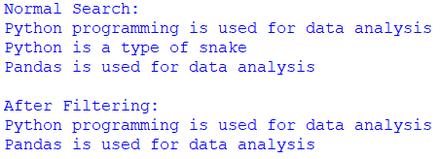
GRAPH:
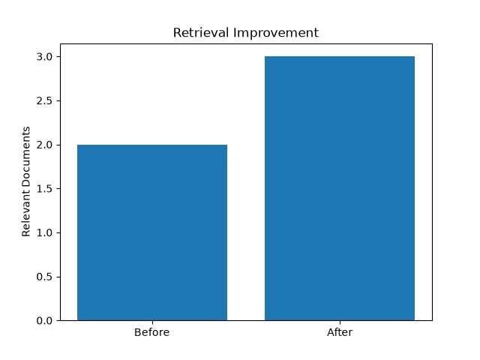
Before improvement:
Query: Python programming for data analysis

Retrieved:
✓ Python programming document
✗ Python snake document
✓ Pandas data analysis document
After improvement:
Query: Python programming for data analysis

Retrieved:
✓ Python programming document
✓ Pandas data analysis document
✓ FAISS/vector-search technology document
✗ Python snake document removed

Analysis
The experiment shows that semantic similarity is useful for retrieving candidate documents, but it should not be the only criterion. Metadata filtering removes documents from irrelevant domains, thresholds remove weak matches, and re-ranking improves the ordering of the remaining documents.

Conclusion
A multi-stage retrieval pipeline provides better relevance than simple vector similarity search. Combining embeddings + vector search + metadata filtering + similarity threshold + re-ranking improves the accuracy and reliability of semantic-search systems.

RUBRICS FOR CALCULATION
Criteria | Wt. | Level 4 (Exemplary) | Level 3 (Proficient) | Level 2 (Developing) | Level 1 (Beginning)
Database Implementation | 30% | Correctly builds and queries both FAISS and ChromaDB with accurate understanding of indexing | Builds both with minor issues | Only one database is built and queried correctly | Neither database functions correctly
Retrieval Relevance & Ranking | 25% | Retrieval results are relevant and correctly ranked for all test queries | Mostly relevant results across queries | Inconsistent relevance across queries | Results are largely irrelevant
Comparative Analysis | 20% | Thoughtful comparison of speed/accuracy trade-offs between the two databases | Reasonable comparison of the two databases | Superficial comparison with little insight | No meaningful comparison attempted
Benchmark Presentation | 15% | Clear benchmark results presented (e.g. table or chart) | Results presented adequately | Results presented unclearly | No clear results presented
Methodology Documentation | 10% | Clearly documents methodology and test queries used | Adequate documentation of methodology | Minimal documentation | No documentation of methodology

Marks Evaluation:
Question No. | Pipeline Functionality(30%) | Answer Relevance & Groundedness (25%) | Query Robustness(20%) | End-to-End Demo(15%) | Architecture Explanation (10%) | Total Marks (100)
Q1
Q2
Overall Total (100)

